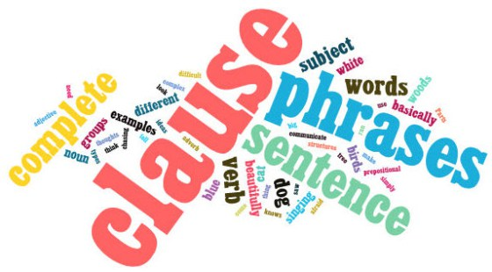
Word
- Write down one word from the article that sums up the subject of the article.
- Write an explanation as to why you chose that word.
Phrase
1. Write down one phrase from the article that relates to the main idea. (Phrase: a sequence of two or more words acting as a unit in a sentence)
2. Write an explanation as to why you chose that phrase and how it relates to the main idea.
Sentence
- Write down one sentence from the article that details the main idea of the article.
- Write an explanation as to why you chose that sentence.

