Webquest- Author’s Craft
3.4.16

DIRECTIONS: Follow the directions below to complete the ‘Author’s Craft’ Webquest

- For the 1st part of this webquest, you must read what I wrote in this document, step-by-step. After you complete each step, you will go onto the next step of the activity. The purpose of this activity is to help you understand author’s craft and the author’s choices when he or she writes their stories and following directions!!!
- Looking at the picture below, pick out the words that the author chose to show how bad the dust bowl was during the 1930’s. Go to your LSPS email (Outlook 365) and start an email to Mrs. Gough (agough@lsps.org). In the subject line of the email, write those ‘bias’ words that the author chose. Keep this email open in another window.

- Go to Google Search or another search engine. Using different keywords, find a poem that uses repetition like the one below. Click on the picture and copy and paste it into that same email. Or, you could find the poem and copy several lines into the email. DO NOT send the email yet.
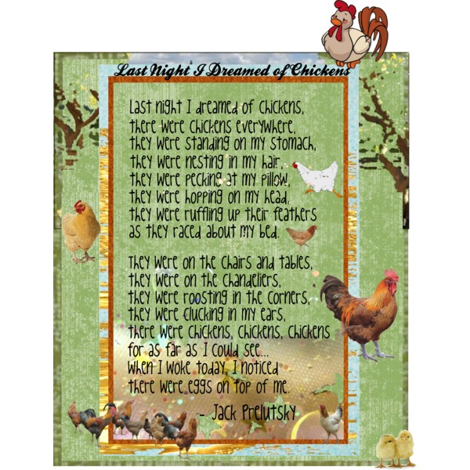

- Below that poem, describe why the author chose to repeat those certain words or phrases. DO NOT describe what the poem is about, but describe the effect the repetition creates?
- Send that email to Mrs. Gough at agough@lsps.org
- Foreshadowing is an author’s skill that sets up the story by hinting at what will happen later.
EXAMPLE: The boy was well-behaved, but only he knew the truth…

Visit the webpage, http://www.purposegames.com/game/foreshadowing-quiz and take the quiz until you get 4 out of 5.

- Now, turn to a person next to you and tell them your favorite part of The Outsiders book. Also, tell them about a choice the author made that you liked the most.

- Author’s voice is the individual writing style of an author, which includes: the tense they use in their writing, the personality they write with, opinions or bias they use, the words they choose, punctuation use, and overall meaning.
-Read over the persuasive sentences below. THEN, rewrite it as informative and serious, removing all opinions and bias. Comment on the post with your new paragraph.
http://goughkms.weebly.com/authors-craft-responses

This is under the ‘The Outsiders’ link at the top of my Weebly
One touch and the screen comes to life. Oh! What a screen! This is eyeball-scorching widescreen clarity too. It would be great for watching streaming videos. Wow! Someone pinch me, because I must be dreaming.
- For your last step, you’ll review over the Author’s tone and mood using an online Quia quiz, https://www.quia.com/rr/773882.html

