Text Structure | Graphic Organizers | Critical Words | Types of Writing | Examples
Description  - A topic, idea, person, place, or thing is described by listing its features, characteristics, or examples |  | Descriptive adjective and words like: on, over, beyond, within | Defining a certain person, place, thing, or idea and its’ parts: The Titanic and its’ features, a Grapefruit, Target, Captain America | Whenever I see that big, red bulls-eye, I have to pull in and check it out: Target, the store that has everything. From a cute new top with elephants on it to Febreeze scented window cleaner, there isn’t anything you can’t find at Target.
Problem/Solution  - Tells about a problem/ why there is a problem and gives one or more possible solutions |  | Propose, conclude, a solution, the reason for, the problem or question | Newspaper articles, an advice column, a situation in life, Social Studies reports, Science fair projects; Solving the problem of higher-price bacon, when a student is failing a class, create solutions for world hunger/ poverty | I just had to have those pajama pants. They would be perfect for pajama day at school. The Target at 15 and Gratiot did not have my size. What on earth was I going to do? I decided to have an associate check to see if another store near me had them available in my size. No such luck. Then I remembered… the internet. I could check to see if they had them online.
Time/Order Chronological  - Tells the order in which an event took place |  | First, second, before, after, finally, then, next, earlier | Describing/ retelling a specific event, set of events in our history, special moment/ memory from your life; How did Lincoln win the Civil War, the series of days leading up to the Super Bowl, how a runner must train for a marathon | You can’t just walk into Target on a whim and plan to shop for just a couple of things. By the time you leave your basket will be overflowing with a bunch of items you do not need and that you probably cannot afford. That is why you have to plan your trip to Target. The first thing you have to do is check the sales paper and mark down anything you need that is on sale. Next you need to check your Cartwheel for the weekly specials and additional coupons and add them to your Cartwheel account. Now you need to make a list of the additional items you will need to purchase (and stick to it). Now you are finally ready to enter the store.
Comparison/ Contrast  - Shows how 2 or more things are alike and different | 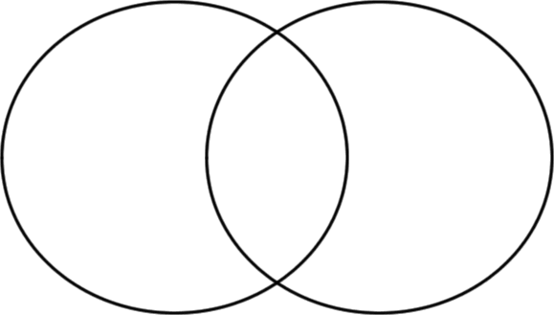 | While, yet, but, rather, most, same, either, as well as, like, and unlike, as opposed to | Science/ Social Studies topics, showing similarities and differences between topics; One Direction vs. 5 Days of Summer, Emporer Penguins vs. Rockhopper Penguins | Although there is no comparison in my mind, some people think Target and Walmart are the same kind of store. They do have some things in common, like the fact they are both big box stores, they both sell groceries clothing, and electronics, and there is usually one every couple of miles off of the main highways. But that is where the similarities end between the two. Target has so many more things to offer. First of all their clothes are of a much better quality and they offer a better selection of styles for all genders and ages as opposed to Walmart where their clothing falls apart after one wear.
Cause/Effect  - Describes an event (cause) and the effects that follow |  | Because, since, if/then, due to, as a result, for this reason, on account of, consequently | Analyzing an event in the past, predicting the future, looking closely at an event in your life, what happens after a particular action; End of civil war, how did the characters change after the events in The Outsiders?, winning the lottery, when you broke your leg, rioting in public and its’ consequences | It was one of the best runs I had ever had at Target. M basket was overflowing with new items for the new house: curtains, throw pillows, picture frames, and decorative
Sequence  - List of steps in a procedure to complete a task |  | To begin, first, next, then, now, finally | Creating a recipe on how to cook or make food, a ‘How-to’ article, explaining to what happened in a book/ situation; Making a Chicken Ceasar Salad, how to fly fish, how to search the internet, explaining to a teacher how you lost your homework, or how did your favorite show end last season | When you first walk into Target you have to stop in the dollar section. There is always something there that I don’t need, but it’s a dollar so who cares. Then you have to check out the newest scarves and purses. Across the aisle make sure you wonder through the clothing department for at least half of an hour.

