**Symbolism**

**What is a Symbol?**

It is a **sign** that stands for something. We look at it and understand the meaning attached to it.

**Part 1:** Look at these symbols and decide what each one stands for or represents, write your answer on a separate sheet of paper.

1.2.  3.4.C:\Users\agough\AppData\Local\Microsoft\Windows\Temporary Internet Files\Content.IE5\6OL4EX4D\MC900229829[1].wmf5.C:\Users\agough\AppData\Local\Microsoft\Windows\Temporary Internet Files\Content.IE5\1X1QE5NQ\MC900292574[1].wmf

______________ _____________ _____________ ___________ ____________

6.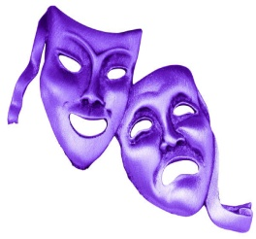 7. 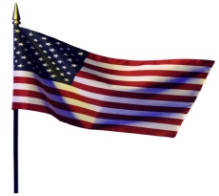 8.C:\Users\agough\AppData\Local\Microsoft\Windows\Temporary Internet Files\Content.IE5\6OL4EX4D\MC900292594[1].wmf 9.C:\Program Files\Microsoft Office\MEDIA\CAGCAT10\j0183290.wmf 10.

_______________ ______________ ____________ __ _____________ _____________

**Part 2:** Think of 3 other symbols that you would recognize immediately. Draw them on a piece of paper – check with the person sitting next to you to ensure they know what they indicate.

1. ___________________ 2. __________________________ 3. ________________________

**Part 3:** Throughout history, certain things have been given symbolic meaning. The same is true of literature, which

often relies on symbolism to convey important thematic concerns.

Some examples:

An Oak tree- often a symbol of strength and endurance.

A Crown- signifies authority and leadership.

A Dove with an olive branch - sign of peace (this originated way back in the

Old Testament with the story of Noah).

See if you can match up the six symbolic items in the first box with what they represent in the second.

Money Cunning War

Idea Night Wisdom

Sword Light bulb Moon

Owl Pound sign (£) Fox

**____________________________________________________________________________________**

**____________________________________________________________________________________**

**____________________________________________________________________________________**

**Part 4:** Design a short message in symbols and write the translation underneath. Do not make it longer than

one sentence. Once you have created your message, exchange with your table partner and ask them to decode it.

E.g.:

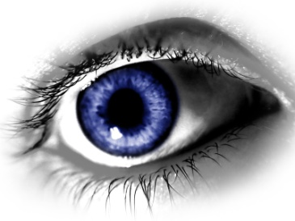  C:\Users\agough\AppData\Local\Microsoft\Windows\Temporary Internet Files\Content.IE5\6OL4EX4D\MC900057355[1].wmf

I (eye) love (heart) you (ewe)!

Decoded message: ____________________________________________________________________________________________________________________________________________________________________________________________________