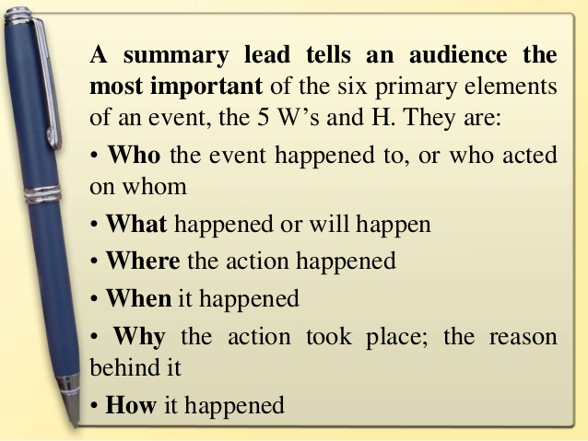
Must be at least 5 sentences!!!!!

