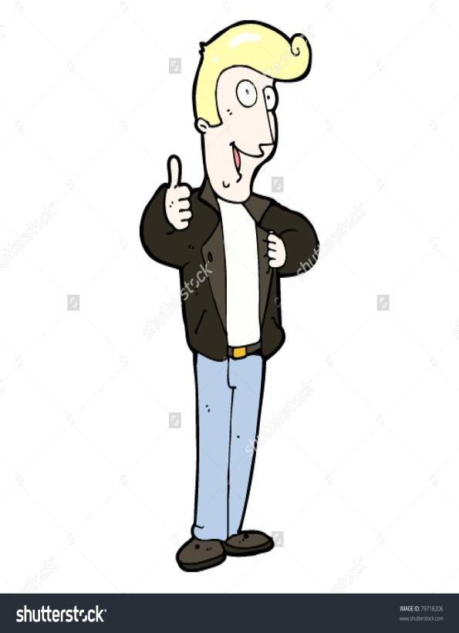
Requirements for profile:
- Drawing of character
- 3 pieces of literal evidence that support the drawing
- 3 ‘Word Art’ character attributes
- 3 pieces of literal evidence (1 each per ‘word art’ attribute)

Dallas Winston Profile
- Wears a leather jacket (p. __, “Sentence or phrase from book that proves he wore a leather jacket” Literal Evidence
- Blond hair (p. ___, “Literal evidence”
- Upbeat and positive (p. ___, “Literal Evidence”

Dallas Winston is timid, because on page 7 of chapter 1, he “cries when chased by the Socs”. This proves he is timid because timid means to be scared or afraid.
-3 people per group; you will be assigned a major or minor character: Pony, Sody, Darry, Steve, Two-Bit, Johnny, Dally, Cherry and Marcia, The Socs

