Mummies have been around longer than you think, scientists say
(Group Blue)
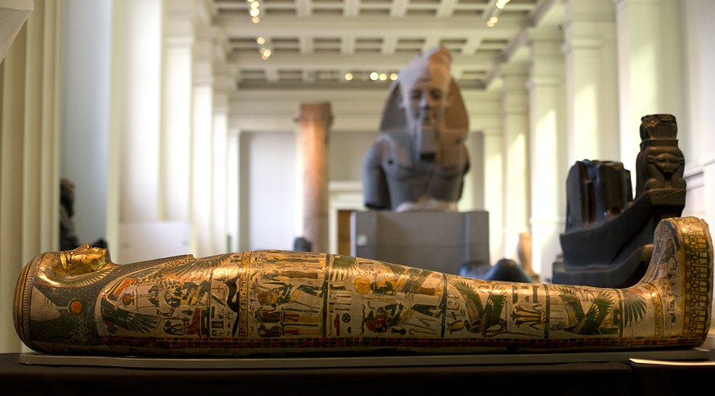
Notes on my thoughts, reactions and questions as
I read:

The ancient Egyptians may have figured out how to make a mummy much earlier than believed. Recently, scientists found signs of mummy-making from 4300 B.C.
That’s about 1,500 years earlier than people thought mummies first appeared in Ancient Egypt. A mummified body is wrapped in cloth. The cloth would be soaked in different chemicals. This embalming process protected the body from rotting away once it was buried.
The process of mixing chemicals together is complicated. Therefore, scientists had previously believed that mummification started around 2500 B.C., during a time period called the Old Kingdom.
However, there is now evidence that the ancient Egyptians may have understood the science of mummification long before that time.

From Egypt's Oldest Cemeteries
Archaeologists work to understand how different people lived in prehistoric times and ancient civilizations. Recently, a small team of archaeologists and other scientists in Australia and England set out to learn more about how mummification traditions developed.
The team looked carefully at a series of funeral cloths used during Egyptian burials. The cloths were found in Egypt's two oldest cemeteries. The cloths were prehistoric and fragile. Some of the fabric still had pieces of bone and skin attached.
Jana Jones and Stephen Buckley led the team. Jones is a scientist and fabric expert. Buckley is an archaeologist who studies the different chemicals that Egyptians used to embalm bodies.
Jones and Buckley used microscopes and other tests to learn more about the cloths. They studied the age of the fabric. They also found unique chemicals on the cloths. They found traces of animal fat, plants, pine and natural petroleum.

"To Be Seen As Sophisticated"
Buckley was able to determine that when mixed together, these chemicals could preserve the wrapped body. This finding reveals that the ancient Egyptians understood the recipe for successful mummification as early as 4300 B.C.

Buckley said that this recipe of chemicals is similar to the recipe that the ancient Egyptians were using 3,000 years later.
Their research will help shape our understanding of mummification.
However, scientific discovery never stops.
There are now even deeper questions that must be answered about ancient burials.
Buckley wants to investigate other funeral sites that are less old. He wants to learn about how mummification traditions developed over time.
“In the past it was almost like these people were not allowed to be seen as sophisticated,” he said. Buckley expects that to change. “Now, because of the science, I hope there will be a big reassessment.”

Comprehension Questions:
1. According to the new evidence found, the process of mummification dates back to:
A. 4300 B.C.
B. 3000 B.C.
C. 2500 B.C.
D. 1500 B.C.

2. All of the following are found in the embalming mixture used for to make mummies EXCEPT:
A. traces of pine
B. traces of bone
C. traces of plants
D. traces of animal fat

3. Select the paragraph from the section "From Egypt's Oldest Cemeteries" that discusses the people who helped to understand the process of mummification.

4. The study of which of the following helped scientists learn that the ancient Egyptians knew the science of mummification?
A. funeral cloths used during Egyptian burials
B. mummification traditions
C. prehistoric civilizations
D. Egyptian burial sites

