Mummies have been around longer than you think, scientists say
(Group Pink)
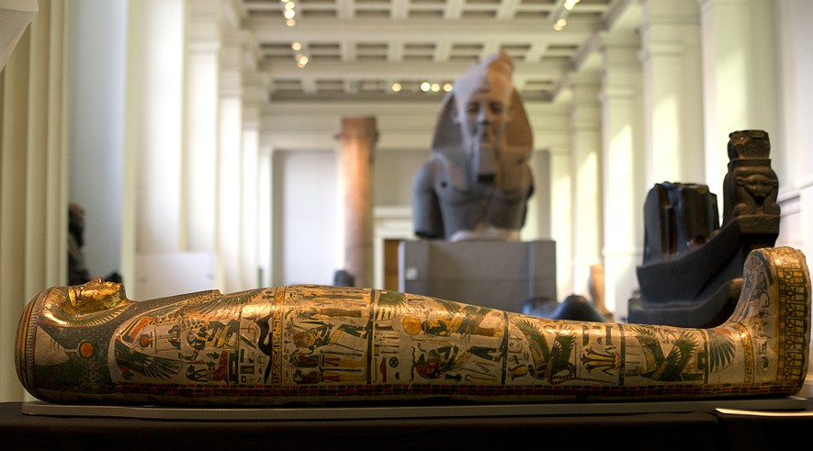
Notes on my thoughts, reactions and questions as
I read:

A mummy is a body wrapped in cloth and buried in the ground. If you look a little closer, you will discover something interesting.
That is exactly what Stephen Buckley and Jana Jones did recently.
Buckley and Jones are scientists and archaeologists. Archaeologists study the humans of the past. Jones studies ancient fabrics and Buckley studies ancient chemicals. They came together to study mummies.
They conducted an experiment to learn more about how the ancient Egyptians wrapped mummies.
They studied cloth from two of Egypt's oldest cemeteries. The cloths are pieces of fabric that were used to wrap mummies.
The scientists were looking for clues that might show when the ancient Egyptians started to make mummies .

An Important Discovery
They used microscopes to look at the small pieces of fabric. Bits of bone and skin were stuck to the cloth. Buckley and Jones were surprised by what they found. There were small amounts of different chemicals on the cloths. They were from plants, animals and natural petroleum.
The chemicals are not usually found on cloth as old as the cloth the scientists looked at. They believe the chemicals were spread on the cloth before a mummy was wrapped. The chemicals would help protect the body after it was buried.
Buckley and Jones made an important discovery.
Their work shows that around 4300 B.C., the early Egyptians understood how to mix chemicals together and wrap bodies in cloth. That is about 1,500 years earlier than many scientists had thought they began making mummies.
In fact, Buckley said the chemicals they found on the old cloth are similar to the ones the ancient Egyptians were using 3,000 years later.

Always Asking Questions
Buckley studies chemicals that were used in ancient cultures. Jones works with different types of textiles.
As scientists, Buckley and Jones are always asking questions.
Buckley now wants to study other burial sites in Ancient Egypt that are less old. He wants to learn how the Egyptians developed their way of burying the dead over the years from 4300 B.C.
Before, people did not think that the early Egyptians were very advanced, Buckley said. He thinks his discovery will change that idea. “Now, because of the science, I hope there will be a big reassessment.”
Comprehension Questions:
1. Jones specializes in the study of:
A. chemicals
B. fabrics
C. microscopes
D. ancient people

2. From the section "Always Asking Questions" select the paragraph that shows what Buckley wants to do next.

3. Buckley and Jones found all of the following on mummy cloths EXCEPT:
A. bone
B. chemicals
C. plants
D. kin

4. What is the profession of Buckley?
A. He is a scientist who studies mummies.
B. He is a scientist who studies bones.
C. He is a scientist who studies ancient chemicals.
D. He is a scientist who specializes in the study of mummy cloths

