Mummies have been around longer than you think, scientists say
(Group Green)
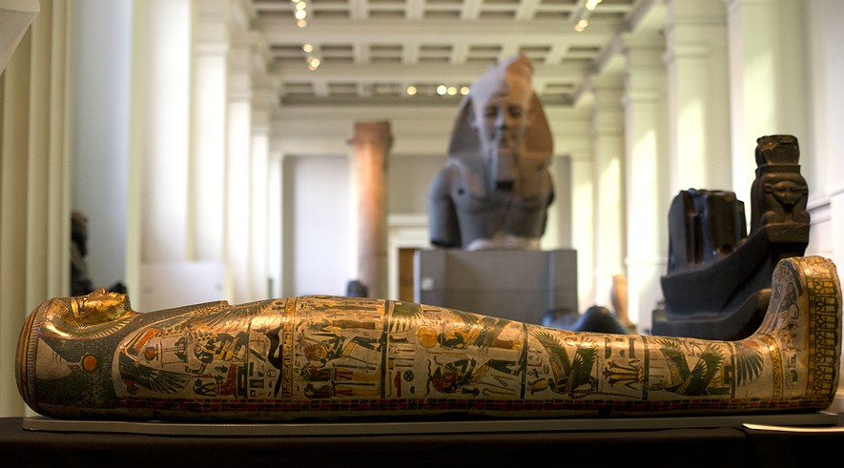
Notes on my thoughts, reactions and questions as
I read:

The ancient Egyptians are famous for creating advanced systems within their prehistoric societies.
They built complex structures like the pyramids. They held elaborate ceremonies. They also developed scientific theories for mysteries they could not explain.
And now, scientists have discovered yet another one of their notable accomplishments.
New evidence suggests that the ancient Egyptians were mummifying their dead as early as 4300 B.C. Archaeologists had previously believed they had not started doing it until 1,500 years later.

How To Make A Mummy
The mummification process is sophisticated. First, it requires the use of special materials, called embalming agents.
During funeral ceremonies, embalming agents would be injected into the body. The chemicals in the agents would keep the body looking similar to how it looked when it was alive.
Mummification also involved wrapping bodies in funeral cloth for further protection.
The ancient Egyptians did all of this to prepare bodies for the afterlife.
Archaeologists previously believed that the early Egyptians did not understand how to use embalming chemicals to preserve bodies as far back as 4300 B.C.
Rather, archaeologists thought that the bodies found during this time period were accidentally preserved by Mother Nature. The hot, desert climate of ancient Egypt was full of dry sand and wind. These natural elements can protect a buried body in ways similar to mummification.
But the latest research, published in the scientific journal PLOS One, suggests something different.

An Early Mummy Mix
A team of scientists recently examined funeral cloths from some of Egypt's oldest cemeteries. They were seeking to better understand how Egyptians buried their dead.
Notes on my thoughts, reactions and questions as
I read:

The team was led by Jana Jones, a textile expert from Sydney, Australia, and Stephen Buckley, a chemical archaeologist from the University of York in England.
Buckley and Jones studied a set of cloths, believed to have been used to wrap body parts during ancient funeral ceremonies. The cloths are part of a collection at the Bolton Museum in northern England. Some of the linens that Buckley and Jones examined even contained pieces of bone and skin.
The scientists put the cloth scraps under microscopes. They performed tests to determine what chemicals were in them. They found the fabrics contained traces of pine resin, animal fat, plant extracts and natural petroleum.
Since these chemicals do not naturally occur on fabrics, the scientists concluded that the Egyptians mixed these materials together to create a type of embalming agent. The agents would have been applied on the cloths around the time of burial.
The findings suggest that body preservation wasn't always an accident in 4300 B.C. The early Egyptians had developed an important and successful recipe for mummification.
Buckley determined that the ingredients used in the sample cloths made up "essentially the same recipe that was used 3,000 years later."

Wrapping The Hands And Head
Some of the cloths even contained a chemical that comes from sea sponges. The embalming mixture also had ingredients that came from as far away as modern-day Turkey. These two interesting finds suggest that the ancient Egyptians may have traveled further and even looked toward ocean life for resources.
Based on the types of materials and the date the linens were used, archaeologists now have a deeper understanding of burial traditions and the scientific knowledge of the early Egyptian culture.
They concluded that the ancient Egyptians understood the powerful effects of embalming chemicals in prehistoric times.
That's not to say they mastered the full mummification process. Even by 3500 B.C. it does not appear that these early Egyptians removed the organs from their dead, as they would later. Also, in the earliest samples, only the hands and the head were wrapped in linen.
Buckley is now interested in looking at slightly later burial sites. His goal is to learn more about how Egyptian civilization developed over time.
“In the past it was almost like these people were not allowed to be seen as sophisticated,” he said. “Now, because of the science, I hope there will be a big reassessment.”

Comprehension Questions:
1. Which of the following is a component of the embalming mixture used by early Egyptians?
A. pieces of skull
B. pieces of skin
C. animal fat
D. linen

2. According to the article, which of the following is NOT CORRECT?
A. The art of mummification dates back to 4300 B.C.
B. Mummification involves the wrapping of the body in linen.
C. Early Egyptians removed the organs from the dead before mummification.
D. The embalming mixture used by early Egyptians sometimes contained a chemical from sea sponges.

3. What is the role of embalming agents in the mummification process?
A. They help in the study of the prehistoric societies.
B. They help in distinguishing the age of mummified bodies.
C. They help to speed up the process of the decaying of the body.
D. They help to slow down the process of the decaying of the body.

4. Select the sentence that explains what archaeologists originally thought caused mummification before 4300 B.C.
A. The mummification process is sophisticated.
B. Rather, archaeologists thought that the bodies found during this time period were accidentally preserved by Mother Nature.
C. The findings suggest that body preservation wasn't always an accident.
D. Also, in the earliest samples, only the hands and the head were wrapped in linen.

