Mission: Space Jump
Austrian skydiver Felix Baumgartner makes a record-breaking 24-mile jump from space
October 15, 2012
By Kelli Plasket with additional AP reporting
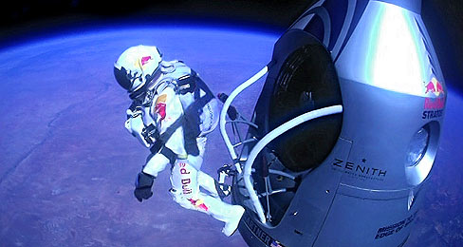
JAY NEMETH—RED BULL STRATOS/GETTY IMAGES
Pilot and skydiver Felix Baumgartner jumps out of a space capsule from an altitude of 128,100 feet during a manned flight for Red Bull Stratos, on October 14.
Austrian Felix Baumgartner—a pilot, skydiver and high-altitude jumper with the nickname “Fearless Felix”—has jumped from some of the world’s tallest bridges and buildings. But on October 14, he made the jump of his lifetime from a space capsule 128,100 feet (about 24 miles) above ground, a world record-breaking height. That distance put him on the edge of space in the stratosphere, the second layer of Earth’s atmosphere.
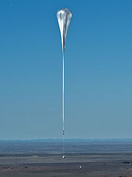
PREDRAG VUCKOVIC—RED BULL STRATOS/GETTY IMAGES
A helium balloon launches from Roswell, New Mexico, to carry Baumgartner and the Red Bull Stratos capsule up to space. It is the largest balloon ever used for a manned flight.
Baumgartner, 42, also broke the record for fastest jump by reaching speeds up to 833.9 miles per hour during his free fall back down to Earth. For comparison, an average Boeing 737 airliner flies at 40,000 feet at 600 miles per hour. At a press conference following the event, Baumgartner said the experience was humbling and harder than he expected. “Sometimes you have to go up really high to understand how small you are,” Baumgartner said.
A Long Way Down
Baumgartner and a team of scientists, engineers and doctors spent five years preparing and training for the project, called Red Bull Stratos after the project’s sponsor. For the space jump, Baumgartner wore a specially designed space suit and was carried up to his jump point by a large helium balloon from inside the Red Bull Stratos space capsule.
Even with careful planning, the mission had some obstacles. The jump was first scheduled for October 8, but it was postponed several times over the week because of weather conditions. Baumgartner finally began the ascent from Roswell, New Mexico, on Sunday, October 14. But on the way up, Baumgartner’s faceplate began to fog up, making it hard for him to see. The team considered aborting the mission, but Baumgartner was able to fix the problem.
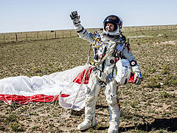
BALAZS GARDI—RED BULL STRATOS/GETTY IMAGES
Baumgartner celebrates after successfully touching ground in New Mexico following his 24-mile jump from space.
After a smooth initial jump, Baumgartner began to spin out of control while still in the stratosphere, but he eventually steadied himself. After four minutes and 20 seconds of free fall—with about a mile left to go in the jump—Baumgartner released his parachute and landed safely in the desert of New Mexico. From Earth, eight million people watched the space jump event live over a YouTube stream.
Breaking New Barriers
Baumgartner’s space jump made headlines for breaking two world records and for making him the first human to break the sound barrier. That’s the speed at which sound waves are produced in the air. But world records weren’t the projects’ only goals. Baumgartner wore a monitoring system to help the crew gather scientific data from the jump. They hope the data will benefit future private space programs and high-altitude pilots. “We’re going to spend a lot of time going through that data. It’s going to break incredible new grounds,” Dr. Jonathan Clark, the project’s medical director, said.
Joe Kittinger, a pilot who set the previous world records for highest and fastest fall over 50 years ago, mentored Baumgartner for the jump. Kittinger still holds the record for longest free fall at four minutes, 35 seconds. “Records are meant to be broken. And better champions cannot be found than Felix Baumgartner,” Kittinger said.
With his own goals completed, Baumgartner hopes to mentor someone else to break the records. “I want to inspire the next generation,” Baumgartner said.

