Introductory Paragraphs
Goals of an Introductory Paragraph in an Historical Account:
- to grab the reader’s attention by raising their curiosity
- to make clear the event you will be writing about and the key moments you will discuss

To achieve the goals above, you must include:
- a hook
- a thumbnail sketch of the historical event
- the central idea (key moments, why they were important and how they’re related)

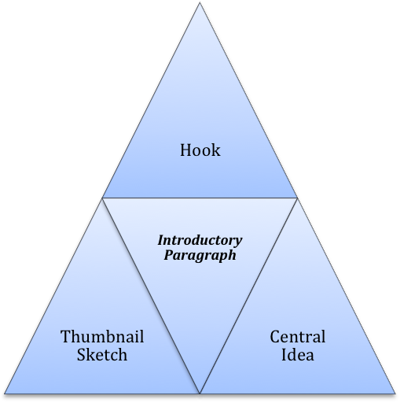
Drafting Strategies

HOOK - Grabbing the Reader’s Attention
- Very briefly provide a specific story (anecdote) from this historical event.
- OR begin with a relevant quotation from an eyewitness account or interview about this event.
- OR describe a scene from this historical event in vivid detail or provide a gripping image.

THUMBNAIL SKETCH – Historical Event Summary
- Provide 3-4 sentences that tell the reader the major points about this moment in history.
  - Who was involved?
  - What happened?
  - Where did this take place?
  - How did this story end?

CENTRAL IDEA
- State the key moments you will discuss.
- Explain why these are the crucial moments in this event and how they are related.

Informational Essay 7: Session 10
Concluding Paragraphs
Concluding paragraphs about history events should discuss:
- why the event was important to a society or culture.
- the impact the event has had on future events.

Example: Hurricane Katrina in New Orleans
From The Institute for New Orleans History and Culture at Gwynedd Mercy College
http://www.gmc.edu/library/neworleans/NOKatrina.htm

New Orleans will be forever changed by this storm. While the old city, the French Quarter and uptown section, survived because they were built on the high ground created by the Mississippi River, the outlying areas where most of its residents lived was destroyed. New Orleans is in a rebuilding phase that some predict will take at least ten years. Many areas of the city may be turned back into green space to absorb future flood waters. Most homes will have to be raised above newly established flood levels. Many wonder if New Orleans will ever recover from this tragedy. But if the spirit of its people prevails, the new New Orleans will be even better than the old.

*****

DIRECTIONS:
To generate strong material for your concluding paragraph, free write about the following questions. Write down everything you know about the answers to these questions. Don’t leave anything out! If you feel you can’t answer any of these questions, you may need to do some more research.

  - Why was your chosen event so important?
  - Why are we still talking and writing about this historical event today?
  - What other things happened as a result of this moment in history? (These could be positive or negative developments.)
  - What people or groups of people did this historical event affect long-term?
  - How did this moment in history affect the economy, arts, jobs, technological advancements, politics, etc. of the area/people involved?

