Marble maidens of ancient Athens are getting a face-lift
(Pink)
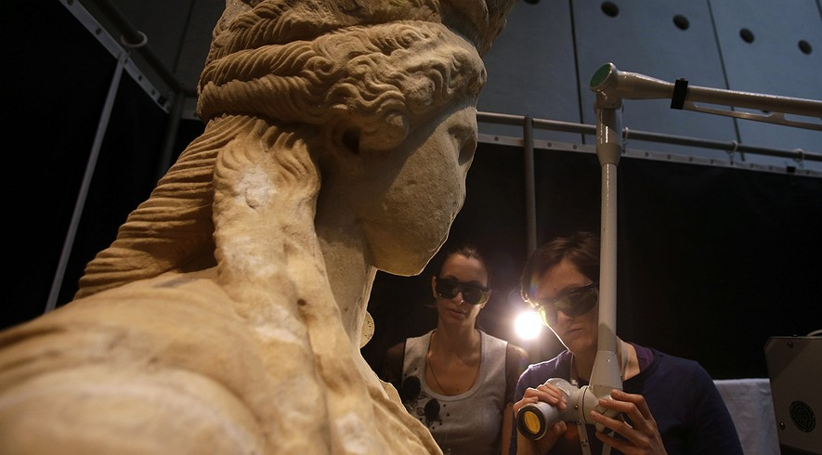
Notes on my thoughts, reactions and questions as
I read:

In this March 28, 2014, photo, conservators use a laser to clean a Caryatid at the Acropolis Museum in Athens. It takes about seven months to clean each of the larger-than-life statues, which were carved around 420 B.C. Work began in 2011, and is expected to be finished in June. Photo: AP Photo/Thanassis Stavrakis
ATHENS, Greece — They are some of Greece's most famous beauties. And after nearly 2,500 years, they're getting a bath.
Not the water kind, though. The Caryatid statues are getting a high-tech cleaning. Workers are using lasers to get rid of the dirt.
The Caryatids are marble columns. They are carved in the form of women. They once held up the roof of the Erechtheion Temple on the Acropolis hill. The Acropolis held some of the most famous buildings of the ancient world.
At the Acropolis Museum, workers zap away dirt from the marble ladies. The workers wear goggles. They are surrounded by a white curtain. The curtain protects visitors from the laser beams. The lasers would hurt their eyes.
There used to be six Caryatids. About 200 years ago, an English lord took one of them. Today, it stands in London's British Museum. Greece put the other five in the Acropolis Museum. This protects them from air pollution and smoke outside.
The Caryatids were carved nearly 2,500 years ago. The Erechtheion Temple was holy to the Greek gods. In later times, it served as a church and a palace. Work on the statues began in 2011. The work will be finished in June.

Using Special Lasers
It takes about seven months to clean each statue.
The workers use special lasers. The lasers break up the dirt. The lasers don't hurt the marble underneath. The cleaning "is done with very great care to avoid any possible damage," said Dimitris Pantermalis. He is in charge of the museum
Visitors can watch the work on screens.
"We want to offer visitors a backstage peek," he said.
Visitors are impressed. "It does bring it home to you the actual level of care that is needed to bring these back to life," said Trevor Richards. He is a tourist from England. "It's like (a makeover) for statues isn't it?"
Notes on my thoughts, reactions and questions as
I read:

Sometimes, the workers get unwelcome guests. People pull back the curtain.
When they started, the workers tried to be quiet. "We always had in mind that we might disturb visitors," Costas Vassiliadis said. Vassiliadis heads the six-person cleaning team. "Only it's the other way round."
The visitors bother the workers.
Comprehension Questions:
1. How long does it take to clean one statue?
A. 3 months
B. 6 months
C. 7 months
D. none of the above

2. The repair work of the statues is being done in:
A. a church
B. a palace
C. the Acropolis museum
D. the Erechtheion temple

3. What does the headline help the reader understand about the article?
A. It tells that the statues were cleaned and who cleaned them.
B. It tells where and how the statues were cleaned.
C. It tells where the statues come from and what they are made of.
D. It tells how the statues looked before they were cleaned.

4. That is the second section of the article about?
A. The dirt on the statues.
B. The future of the statues.
C. The history of the statues.
D. The tools used to clean the statues.

