Marble maidens of ancient Athens are getting a face-lift
(Green)
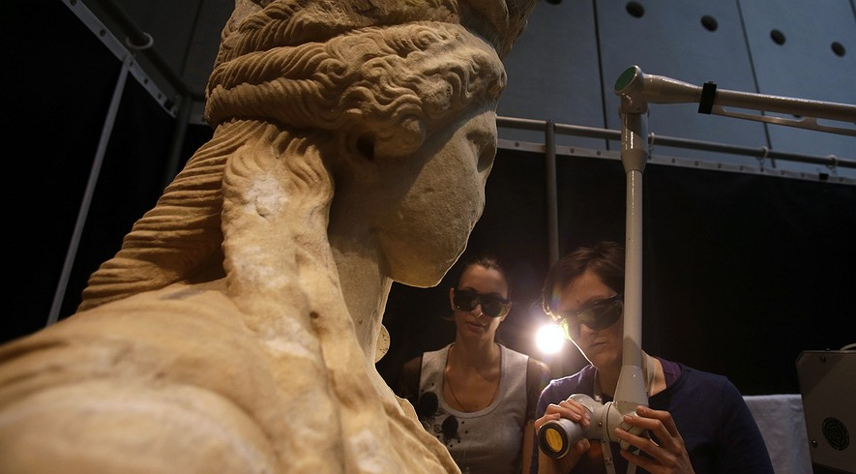
Notes on my thoughts, reactions and questions as
I read:

In this March 28, 2014, photo, conservators use a laser to clean a Caryatid at the Acropolis Museum in Athens. It takes about seven months to clean each of the larger-than-life statues, which were carved around 420 B.C. Work began in 2011, and is expected to be finished in June. Photo: AP Photo/Thanassis Stavrakis
ATHENS, Greece — They're some of Greece's most famous beauties. And after nearly 2,500 years, it's perhaps only fitting that they're getting a face-lift.
The Caryatid statues on Athens' Acropolis are being carefully cleansed of grime inside the Acropolis Museum where they're now housed.
Three goggle-wearing conservators zap away dirt from the marble maidens with custom-designed lasers. They are surrounded by a white fabric screen to protect visitors from laser beams, which can cause permanent eye injury. Tourists watch the work from a distance on monitors.
The Caryatids are columns sculpted in the form of women that once propped up a section of the Erechtheion Temple on the Acropolis. The Acropolis is a hill in Athens that contains some of the most beautiful and well-known buildings of the ancient world. One of the six Caryatids was removed by Lord Elgin in the 19th century and today stands in the British Museum. The other five were removed from the Erechtheion in 1979 to protect them from air pollution and acid rain, and replaced by copies.

Cleaning Years Of Grime
Museum director Dimitris Pantermalis said the main reason for cleaning the sculptures on the spot was to avoid the potential hazards of moving them. But there's the additional value of offering tourists the spectacle of restoring some of the greatest glories of the ancient world.
"We want to offer visitors a backstage peek," he said.
Visitors are impressed. "The fact that it was ... taking place in the museum, it does bring it home to you the actual level of care that is needed to bring these back to life," said British tourist Trevor Richards, from Manchester. "It's like cosmetic surgery for statues isn't it?"
It takes about seven months to cleanse each of the larger-than-life statues, which were carved around 420 B.C. Work on the statues began in 2011, and is expected to be finished in June.
"The process removes all of the pollution, the smoke and everything that has settled on the statues for more than a century," Pantermalis said. The lasers leave intact the statues' patina, the thin, orange-colored layer that developed with the passage of centuries. "It's done with very great care to avoid any possible damage," he said.
The Erechtheion Temple was sacred to the gods Athena and Poseidon, and associated with the first kings of Athens. In later times, it served as a church, a palace for the Germanic tribes that ruled most of Europe in the early Middle Ages, and a Turkish harem.
Notes on my thoughts, reactions and questions as
I read:

Pillars Of The Statue World
Greece's oldest examples of pillars in the human form are a century older than the Caryatids. But the Caryatids are the most famous of their kind, and were widely imitated from Roman times to Europe's classical revival in the 18th century.
Conservators use technology developed specially for the Acropolis sculptures by the Foundation for Research and Technology-Hellas in Crete. The technique combines two infrared and ultraviolet wavelengths, to avoid scratching the statues or causing discoloration.
"The laser beam hits the black crust formed on the surface of the statues over the years, and that absorbs energy and disintegrates," said Costas Vassiliadis. He heads the six-person conservation team. The filthy crust has a much lower tolerance than the marble, which is not affected.
Laser operators spend a maximum three hours on the job every day. Sometimes they get unwelcome guests.
"At first we felt slightly stagestruck, we tried to avoid making any noise, and always had in mind that we might disturb visitors," Vassiliadis said. "Only it's the other way round, as visitors several times draw back the curtain — which they really shouldn't as laser is dangerous for the eyes."

Comprehension Questions:
1. Which of the following about the Caryatid statues is NOT TRUE?
A. The statues are nearly 2,500 years old.
B. The famous statues are made of marble.
C. The first restoration work was done in 1979.
D. The statues were a part of the Erechtheion Temple.

2. Select the paragraph from "Cleaning Years Of Grime" that focuses on the procedure for cleaning the statues.

3. Read the following paragraph from the text:
They're some of Greece's most famous beauties. And after nearly 2,500 years, it's perhaps only fitting that they're getting a face-lift. How does the fourth paragraph of the article explain why it is "fitting" that the beauties are getting a "face-lift"?
A. The fourth paragraph talks about the importance of Greek architecture and how damaged parts of the temple have become, thus needing a "face-lift".
B. The fourth paragraph describes the appearance and history of the sculptures and the damage they sustained over time.
C. The fourth paragraph discusses the removal of the statues, comparing it to the removal of impurities during a face-lift.
D. The fourth paragraph explains where the statues are from, while the first paragraph describes how old they are.

4. Read the sentence from the article.
Conservators use technology developed specially for the Acropolis sculptures by the Foundation for Research and Technology-Hellas in Crete.
What was the purpose of the author to include this sentence in the article?
A. to show the advancement in technology used to clean the statues
B. to show the efforts taken by conservators to protect the statues from harm while cleaning them
C. to shift focus to years of damage done to the statues as a result of pollution and acid rain

D. to highlight the extent of damage done to the statues that required such advanced technology

