Figurative Language
Figurative language is the use of words that go beyond their ordinary meanings. Figurative language requires you to use your imagination to figure out the author's meaning.

SIMILE
Simile: comparing two things using “like” or “as”
Example: Her hair was as golden as the sun.
What is being compared? Her hair to the sun.
METAPHOR
Metaphor: comparing two things without using like or as
Example: My dad is a big teddy bear.
What is being compared? My dad to a teddy bear.
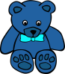
ONOMATOPOEIA
Onomatopoeia: a word or words that imitate a sound
Example: Whack! Bang! Buzz! Snap!
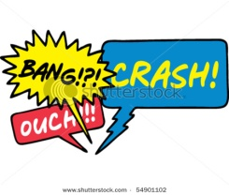
PERSONIFICATION
Personification: giving human characteristics to things that are not human
Example: My locker bit me.
Reality: My finger was stuck in my locker.

