CDC study: Fast food flourishes among many U.S. children
By Los Angeles Times, adapted by Newsela staff
10.07.15
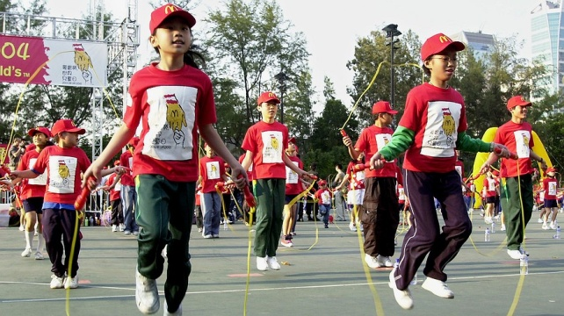
Some of the more than 1,000 children skip rope at Hong Kong's Victoria Park during World Children's Day organized by fast-food chain McDonald's on Nov. 20, 2004. Photo: AP/Lo Sai Hung
At least 1 out of 3 American children and teens will eat fast food today.
T4 Notes go here
A government report says many children will eat fast food tomorrow and the next day.
Each day, 34.3 percent of children and teens eat pizza, fried chicken or another fast-food dish. The information is from the Centers for Disease Control and Prevention (CDC).

For Young People, Many Calories Come From Fast Food
Out of those young people, 12.1 percent will get more than 40 percent of their daily calories from a fast food restaurant. A calorie is a unit of energy in food. Too many calories can make people gain weight. 10.7 percent of children and teens will get 25 percent to 40 percent of their daily calories from a fast-food restaurant. Another 11.6 percent will still eat fast food, but not as much. They will get fewer than 25 percent of their calories from it.
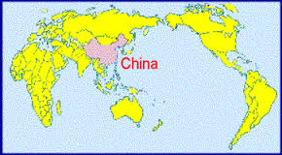
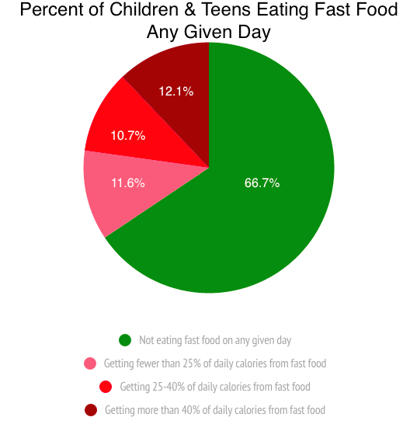
T4 Notes go here
What does this all mean? Children and teens eat too much fast food. Every day, for every 8 calories children eat at home, at school or at restaurants, 1 calorie will be from fast food.
This was true for both boys and girls. It also did not matter whether the children and teens were rich or poor. Even weight did not have much to do with a hunger for fast food. Underweight, normal weight and overweight children all got about the same number of calories from fast food.

Asian-American Youths East Less Fast Food
There was one big difference, though. Asian-American children and teens were less likely than other youths to eat fast food. About 8 out of 100 Asian-American children ate fast food on any day. This can be compared to 11 out of 100 Latinos, 13 out of 100 whites and 14 out of 100 African-Americans.
The scientists think fast food is not as popular in Asian-American families. They are not as interested in American food. For every 100 Asian-American children, about 27 of them were born in another country. More Latino children, white children and black children were born in the United States.
Age was another important difference. Older children and teens were more likely to eat fast food than younger children. On a typical day, 9 out of 100 younger children, ages 2 to 11, ate fast food. A total of 17 out of 100 older children and teens, ages 12 to 19, did so. It did not matter whether the children were boys or girls, rich or poor, or skinny or heavy. It also did not matter where the child's family came from. The pattern was always the same.

