Many younger Americans have a fast-food focus
By Los Angeles Times, adapted by Newsela staff
10.07.15
Some of the more than 1,000 children skip rope at Hong Kong's Victoria Park during World Children's Day organized by fast-food chain McDonald's on Nov. 20, 2004. Photo: AP/Lo Sai Hung
More than 1 out of 3 American children and teens will eat fast food today.
The same will be true tomorrow, and the next day, and the day after that, according to a new report.
T4 Notes go here
Every day, 34.3 percent of children and teens eats pizza, fried chicken, tacos or another fast-food dish. The report was published Tuesday by the Centers for Disease Control and Prevention (CDC) National Center for Health Statistics.

No Difference For Gender, Income
More specifically, 12.1 percent of these young diners will get more than 40 percent of their daily calories from fast food. Another 10.7 percent will get 25 percent to 40 percent of their daily calories from a fast food restaurant. 11.6 percent will get fewer than 25 percent of their calories from it.
What does this all mean? On average, the youth of America get 12.4 percent of their calories on a bun, out of a deep fryer or fast-food grill every single day.
This holds true for boys and girls, toddlers and teenagers. The proportion of daily calories obtained from fast food was the same for both genders, according to the report.
Nor did it matter whether diners were rich or poor. Children from poor families counted on fast food for 11.5 percent of their daily calories, on average. Children from wealthy families averaged 13 percent of their daily calories from fast food. That gap was not big enough to be significant, the report said.
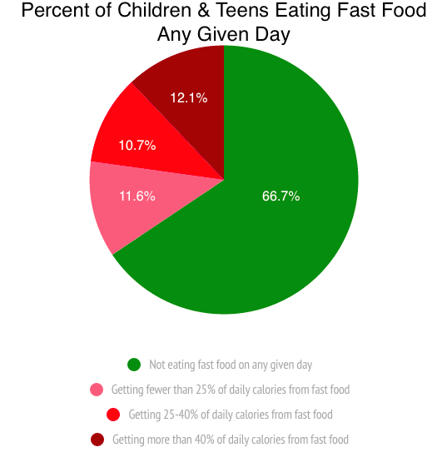

Race Makes A Difference
T4 Notes go here
Even weight did not have much to do with a hunger for fast food. Both underweight and normal weight children got 12.2 percent of their daily calories from fast food. Overweight children got 11.6 percent of their calories from fast food. For those who are obese, it was 14.6 percent. Again, those differences were too small to be important.
Researchers found a big difference. Asian-American children and teens were less likely than their peers to visit a fast-food restaurant. On average, only 8 percent did so on any given day. This can be compared with 11.2 percent of Latinos, 13.1 percent of whites and 13.9 percent of African-Americans.
The researchers speculate that fast food had not caught on as much in Asian-American households. These families were not as integrated into the U.S. lifestyle, including its eating habits. Fully 27.4 percent of Asian children in the United States were born overseas. This can be compared with 19.7 percent of Latino children, 2.5 percent of whites and 1.9 percent of blacks.

Age Also Makes A Difference
The other important difference had to do with age. Overall, children between ages 2 and 11 were much less likely than teens, ages 12 to 19, to eat fast food. On a typical day, 8.7 percent of the younger children ate fast food, compared with 16.9 percent of older children. That pattern was seen regardless of sex, race or ethnicity, weight or family income, the researchers found.
The report was based on information from the CDC’s 2011-2012 National Health and Nutrition Examination Survey.

