CDC reveals just how much fast food American kids eat each day
By Los Angeles Times, adapted by Newsela staff
10.07.15
Some of the more than 1,000 children skip rope at Hong Kong's Victoria Park during World Children's Day organized by fast-food chain McDonald's on Nov. 20, 2004. Photo: AP/Lo Sai Hung
T4 Notes go here
More than one in three American kids will eat fast food today, a new government report says.
The same will be true tomorrow, and the next day, and the day after that.
On any given day, 34.3 percent of U.S. children and teens between the ages of 2 and 19 eats pizza, fried chicken, tacos or some other dish prepared in a fast-food restaurant, according to data collected by the Centers for Disease Control and Prevention.
More specifically, 12.1 percent of these young diners will get more than 40 percent of their daily calories in the form of fast food. An additional 10.7 percent will trace 25 percent to 40 percent of their daily calories to a fast-food joint, and 11.6 percent will get fewer than 25 percent of their calories from one of these dining establishments.
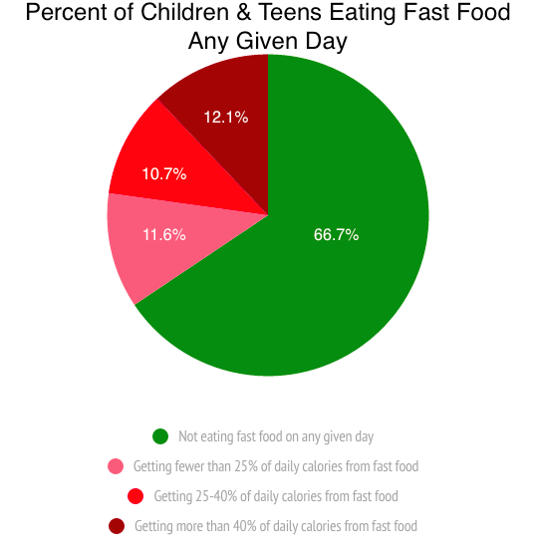
When you average it all out, the youth of America get 12.4 percent of their calories on a bun, out of a deep fryer or from another quintessentially fast-food source every single day.
T4 Notes go here
It doesn’t matter if these diners are boys or girls. Whether toddlers or teenagers, the proportion of daily calories obtained from fast food was statistically equivalent for both genders, according to the report published Tuesday by the CDC’s National Center for Health Statistics.
Nor did it matter whether diners were rich or poor. Children from families who were close to the poverty line counted on fast food for 11.5 percent of their daily calories, on average. Children at the other end of the economic spectrum averaged 13 percent of their daily calories from fast food. That gap wasn’t big enough to be considered statistically significant, the report said.
Even weight status had little bearing on the appetite for fast food. Children and teens who were underweight or had a normal weight averaged 12.2 percent of their daily calories in the form of fast food. That was slightly higher than the 11.6 percent for overweight youths and slightly lower than the 14.6 percent for those who are obese. Again, those differences weren’t big enough for the researchers to say they were real.
There was a significant difference in fast-food consumption according to race and ethnicity. Asian-American children and teens were less likely than their peers to visit a fast-food joint: Only 8 percent did so on any given day, on average. That compared with 11.2 percent of Latinos, 13.1 percent of whites and 13.9 percent of African-Americans. The differences among non-Asian youths were not statistically significant.
The researchers speculated that fast food hadn’t caught on as much in Asian-American households because these families weren’t as assimilated into the U.S. lifestyle, including its eating habits. Fully 27.4 percent of Asian children in the United States were born overseas, compared with 19.7 percent of Latino children, 2.5 percent of whites and 1.9 percent of blacks.
The other significant difference had to do with age. Overall, children between the ages of 2 and 11 were much less likely than adolescents between the ages of 12 and 19 to dine on fast food. On a typical day, 8.7 percent of the younger children ate fast food, compared with 16.9 percent of older children. That pattern was seen regardless of gender, race or ethnicity, weight status or family income, the researchers found.
The report was based on data from the CDC’s 2011-2012 National Health and Nutrition Examination Survey.

