Shrine within a shrine reveals evidence of when Buddha was born
Group Pink
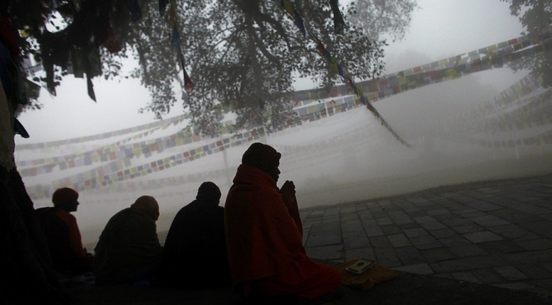
Nepalese Buddhist monks offer prayers early morning at the Maya Devi Temple at Lumbini, the birthplace of the Buddha, southwest of Katmandu, Nepal, Saturday, Jan. 14, 2012. Photo: AP Photo/Niranjan Shrestha
Notes on my thoughts, reactions and questions as
I read:

More than 350 million people around the world follow the teachings of the Buddha. They call themselves Buddhists. The beliefs and traditions of Buddhism are ancient, yet nobody is sure exactly when the Buddha was born. Now, new evidence found in Nepal may help fill in the timeline for the world's fourth largest religion.
Archaeologists dug underneath a temple where people visit to pay respect to the Buddha, or "enlightened one." They discovered ancient bricks, tile roofing and wood charcoal. An archaeologist's job is to piece together the mysteries of the past by uncovering artifacts buried underground.
The archaeologists' findings were published this week in a magazine. Historians have thought that the Buddha could have been born anywhere between 623 B.C. and 340 B.C. But, the researchers at the dig say the evidence shows that Buddha was born in the 6th century B.C. That's 600 years before the birth of Christ. Since we live 2,013 years after the birth of Jesus, the Buddha was born 2,600 years ago.
The exact day and year date that the Buddha was born is still not known.

A Temple Built Of Wood
The problem is that nothing was written down about him during his life. Writings on monuments that were built in his memory have been found. The Indian emperor Ashoka built several in the 3rd century B.C. Those provide some clues. But, there isn't much evidence from before that.
The team dug at the Maya Devi Temple at Lumbini. Buddha is believed to have been born at the site of that temple. The scientists dug inside to find the buried temple.
Robin Coningham led the team that did the digging. What they found was a temple built of wood. It had not been discovered before. Several brick temples had been later built on top of it.
The original wood structure appears to have been built around an open space. In that space was a tree, the team thinks.
The center of the temple had been open to the sky. "It had never been covered by a roof,” Coningham said. Also, the team found pieces of tree roots that had been preserved.
Buddhists say that the Buddha was born in a garden, beneath a tree. His mother was Queen Maya Devi. She grabbed onto a tree branch to hold herself up while giving birth. Immediately after his delivery, Buddha is said to have stood and walked.
That's why it makes sense that a tree would have such an important place in the shrine.

Born Siddhartha Gautama
Coningham said what they found is very rare. It's not often that what you find at a dig matches up with beliefs held by people hundreds of years ago. And the scientific tests done later agreed with what they found as well.
Notes on my thoughts, reactions and questions as
I read:

The Lumbini temple is one of four important temples in the life of Buddha. The others are Bodh Gaya, where he attained enlightenment; Sarnath, where he first preached; and Kusingara, where he died at age 80.
The Buddha's original name was Siddhartha Gautama. He got the name of Buddha after he reached a great level of knowledge and wisdom, also called enlightenment.
The Buddhist religion was very small at first. The original Lumbini temple was probably built by rich followers of Buddhism.
Later temples were built with large open areas as well, scientists said.

Testing The Building's Age
At some point, the temple was forgotten and jungle grew around it. It was rediscovered in 1869 and was found to have a large sandstone column. On it was written that the place is called Lumbini and that emperor Ashoka had visited there.
Scientists said earlier temples were covered by new buildings. That's why it wasn't possible to see what was buried until now.
The scientists used bits of charcoal from the early wooden temple and grains of sand to test how old the building is. By looking at how long certain things take to decay or fall apart, scientists can find out how old something is.
Hundreds of thousands of monks, nuns and pilgrims visit Lumbini each year to pay respect to the Buddha. And the temple remained open to them as the archaeologists did their dig.
“All of this work occurred within a living temple,” Coningham said.
Comprehension Questions:
1. The archaeologists found all of the following at the site EXCEPT:
A. tile roofing
B. ancient bricks
C. wood charcoal
D. precious metals

2. What happened in 1869?
A. The temple was destroyed.
B. Buddha achieved enlightenment.
C. The original Lumbini temple was rediscovered.
D. Another temple was built over the Lumbini temple.

3. Why is Sarnath an important place for Buddhists?
A. Buddha achieved enlightenment in Sarnath.
B. Buddha first preached in Sarnath.
C. Buddha was born in Sarnath.
D. Buddha died in Sarnath.

4. Select the paragraph from the article that explains why it is hard to find the exact day the Buddha was born.

