Shrine within a shrine reveals evidence of when Buddha was born
Group Blue
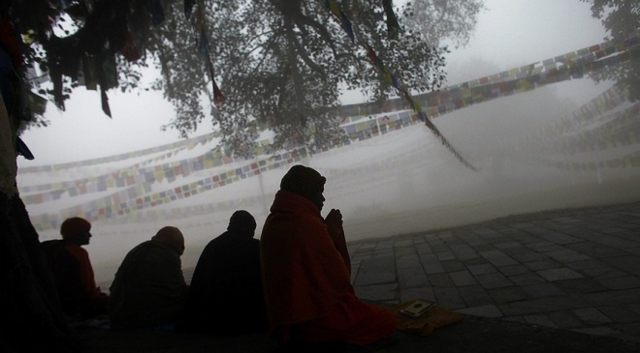
Nepalese Buddhist monks offer prayers early morning at the Maya Devi Temple at Lumbini, the birthplace of the Buddha, southwest of Katmandu, Nepal, Saturday, Jan. 14, 2012. Photo: AP Photo/Niranjan Shrestha
Notes on my thoughts, reactions and questions as
I read:

Ancient bricks, tile roofing and wood charcoal discovered beneath a site in Nepal where monks, nuns and pilgrims visit to honor Buddha are providing new evidence for when he might have been born.
In research published this week in the journal Antiquity, scholars wrote that the evidence supports a 6th century B.C. birth for the Buddha, or "enlightened one." Historians have often thought he was born between 623 B.C. and 340 B.C.The exact date that Buddha was born remains unknown.
Much of the confusion has to do with the lack of a written record. Inscriptions written on monuments that were paid for and erected by the Indian emperor Asoka, or Ashoka, in the 3rd century B.C. provide some clues. But, earlier evidence is harder to come by, researchers say.

A Wooden Temple Uncovered
The Antiquity paper focused on recent archaeological work at the Maya Devi Temple at Lumbini, said to be the site of Buddha’s birth. The dig, which was financed by the Japanese and Nepalese governments and the National Geographic Society, was done within the shrine.
Robin Coningham led the team that dug out the shrine. He's also a professor of archaeology in Britain. He said the dig revealed a previously undiscovered temple built of wood. It wasn't discovered before this because several brick temples had been built on top of it.
The original timber structure appears to have been built around an open space. A tree was probably in the middle of that space, the team says.
“This central portion of the temple had always been open to the elements. It had never been covered by a roof,” Coningham said. “Also, the team found fragments of mineralized tree roots.”
According to Buddhist tradition, Siddhartha Gautama, as he was known before he became enlightened, was born in a garden, beneath a tree. His mother, Queen Maya Devi, held a tree branch for support while she gave birth, and immediately after his delivery, Buddha is said to have stood and walked.
Coningham said that because of this belief, it was not surprising that a tree would feature prominently in the shrine.“This is one of those rare occasions when belief, tradition, archaeology and science actually come together, because here we have a very early shrine built around a tree,” Coningham said.

Forgotten And Overgrown
Notes on my thoughts, reactions and questions as
I read:

The Lumbini temple is one of four key temples associated with the life of Buddha. The others are Bodh Gaya, where he attained enlightenment; Sarnath, where he first preached; and Kusingara, where he died at age 80.
The first Lumbini shrine was likely built by wealthy followers of Buddhism at a time when the religion was considered a cult. New religions with very few followers are sometimes seen as cults.Later shrines were constructed with large open areas as well, researchers said.
At some point, the temple was forgotten and overgrown by jungle. It was rediscovered in 1869 and found to have a large sandstone column with an inscription that called the site Lumbini and said that emperor Ashoka had visited there.
Researchers said most of those earlier shrines at the site were covered by more recent construction, and an examination of the buried materials was not possible until now.

Carbon And Optical Dating

The researchers used fragments of charcoal from the early wooden temple and grains of sand to date the structure. The tests involved a combination of carbon dating and optical dating, the authors of the study said.
Carbon dating can tell how old something is by measuring how much the carbon has decayed. Carbon is found in nearly everything, including the bodies of humans. In optical dating, by shining a light on minerals that had been buried scientists can tell when was the last time they saw daylight.
Hundreds of thousands of pilgrims visit Lumbini each year, and the temple remained open as the archaeologists conducted their work.“All of this work occurred within a living temple,” Coningham said.
Comprehension Questions:
1. According to the article, all of the following provide evidence for the place of Buddha's birth EXCEPT:
A. tiles
B. bricks
C. charcoal
D. scriptures

2. What effect does the new finding have?
A. Historians might discover when Buddha was born.
B. Historians can discover the date of Buddha's death.
C. Historians might predict the fall of Ashoka's empire.
D. Historians can find about the spread of Buddhism.

3. Select the paragraph from the article that shows why it is hard to determine the exact date of Buddha's birth.

4. Why had the ancient wooden temple not been discovered until now?
A. Archaeologists were digging in the wrong places.
B. Multiple brick temples had been built over it.
C. Nobody wanted to find out about Buddha.
D. Nepal's government did not allow digging.

