Bracing for a Superstorm
East Coast residents prepare for powerful Hurricane Sandy to make landfall
October 29, 2012
By Kelli Plasket with AP reporting
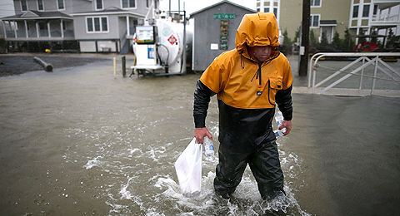
MARK WILSON-GETTY IMAGES
A man in Cape May, New Jersey, walks through flood waters caused by surges of seawater from Hurricane Sandy, on October 29.
Millions of people in the Mid-Atlantic and Northeast stayed home from work and school on Monday as Hurricane Sandy made its way up the Atlantic Coast and turned toward the New Jersey coastline. Sandy extends almost 1,000 miles wide. It is expected to be the largest storm ever to hit the East Coast, affecting more than 50 million people in the most heavily populated areas in the nation.
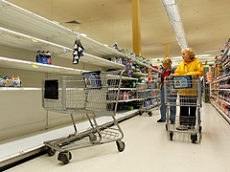
MIKE STOBE-GETTY IMAGES
By Sunday evening, many store shelves in Hurricane Sandy's path were empty of emergency supplies, like this grocery store in Long Beach, New York.
People in the region began preparing for Sandy over the weekend. By Sunday evening, many store shelves were emptied of emergency supplies and businesses were boarded up. Major cities like New York City and Philadelphia suspended public transportation, including trains, subways and buses. Schools were closed. Airlines canceled more than 5,000 flights. Residents of coastal areas from Maryland to Connecticut were ordered to evacuate to inland areas. Emergency crews were put on high alert and prepared to help out.
An Unprecedented Storm
Sandy is a Category 1 hurricane with winds near 90 miles per hour. Tropical storm-force winds extend almost 500 miles from its center. The storm first hit the Caribbean and was blamed for 65 deaths there before making its way north up the Atlantic. A high-pressure ridge of air around Greenland is blocking the hurricane from going out to sea as storms usually do. Instead, the storm is shifting west toward land.
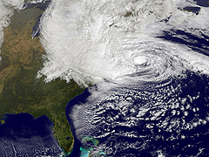
NASA/GETTY IMAGES
This NASA satellite image shows the size of Hurricane Sandy as the eye of the storm heads north up the Atlantic coast on Monday, October 29.
The eye of the hurricane is expected to come ashore late Monday on or near the southern coast of New Jersey. It will collide with a wintry storm from the west and cold air coming down from the Arctic. Snow accumulations of two to three feet are expected in the mountains of West Virginia and from southwestern Virginia to the Kentucky border. In the mountains near the North Carolina/Tennessee border and the mountains of western Maryland, 12 to 18 inches of snow are possible. Brutal winds and close to a foot of rain will be felt across a radius of hundreds of miles. Coastal areas, including parts of New York City and Long Island, are in danger of huge surges of seawater, made worse by high tides and a full moon. "This is the worst-case scenario," said Louis Uccellini, environmental prediction chief for the National Oceanic and Atmospheric Administration.
Nationwide Effects
The effects of the storm are already being felt nationwide. The New York Stock Exchange and other major stock exchanges closed on Monday. It’s the first unplanned closing of the stock exchanges since September 11, 2001. And with just days left until the election on November 6, President Barack Obama and Mitt Romney rearranged their campaign schedules in the wake of news of the hurricane. Maryland and Washington, D.C. canceled early voting for Monday.
President Obama canceled a campaign appearance in Orlando, Florida, that had been scheduled for Monday. He said he would remain at the White House to monitor the storm. Obama signed emergency declarations for New York, New Jersey, Connecticut, Massachusetts, Maryland and Washington, D.C. This will allow federal government aid to help out the hardest-hit areas during and after the storm. "In times like this, one of the things that Americans do is we pull together and we help out one another," President Obama said Sunday. "Check on your neighbor, check on your friend. Make sure that they are prepared. If we do, then we're going to get through this storm just fine."
President Obama assured the public on Monday that officials are ready for the storm. "This is going to be a big and powerful storm," he told reporters. "All across the Eastern Seaboard, everybody is taking appropriate preparations." President Obama urged people in the hurricane's path to follow the instructions of state and local officials.

