A Healthier Happy Meal
Two kids are working with the top chef at McDonald’s to make Happy Meals more nutritious
November 09, 2012
By TFK Kid Reporter Alice Gottesman
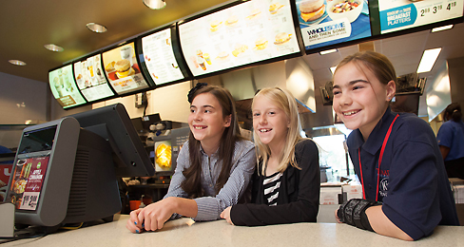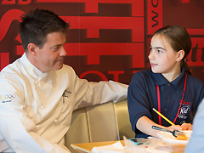
JOHN ZICH—ZRIMAGES FOR MCDONALD'S JOHN ZICH—ZRIMAGES FOR MCDONALD'S

Kid Reporter Alice Gottesman posed with Sarah Ralston and Elanya Saley at McDonald's headquarters in Oak Brook, Illinois.
Fast food is known for being convenient. But when it comes to nutrition, it is not considered to be the best choice. McDonald’s says they want to change that. In July 2011, the company announced a plan to provide customers with healthier options. One change since then has been the addition of apple slices to Happy Meals.
Now, the fast-food chain is enlisting kids’ help to make changes to their kid’s meals, which they call Happy Meals. Sarah Ralston, 11, and Elanya Saley, 9, won a contest to become honorary Happy Meal chefs. Their job is to help the company’s executive chef, Dan Coudreaut, create a healthy new Happy Meal option. “I want to make sure that [kids] are being active and healthy,” Sarah told TFK.
Kids Pitch In

Kid Reporter Alice Gottesman interviews McDonald's executive chef Dan Coudreaut.
At the company’s headquarters in Oak Brook, Illinois, the two girls started by experimenting with pocket food—a term used for food items that have a filling. They made turnovers stuffed with broccoli and cheese, empanadas packed with chicken and vegetables and ravioli made with meat and spinach.
Sarah and Elanya started with pocket foods because it is easy to put vegetables in pocket food. If you can grow all the vegetables in one place and put them in the foods in one place, it’s possible to then ship everything out to the thousands of McDonald’s locations, Coudreaut explained.
According to Coudreaut, making changes to the Happy Meal can be challenging. Even adding apple slices required a great deal of planning. “With 14,000 restaurants, that is a really hard thing to do,” said Coudreaut.
Still, Coudreaut hopes to make many more changes, with the goal of making the meals more nutritious. “We aren’t stopping at apples,” he said.

